Programming Language Research Project

Course: CST 8002-040 Programming Languages Research Project
Assignment: Research Assignment 02
Instructor: Tyler DeLay
Student Name: Qinyu Luo
Student ID: 041137796
Due Date: 09/25
Submitted: September 25

Development Environment Changes
No changes to the development environment since the previous assignment.

Research and Learning Resources
I will use MVC (Model-View-Controller) architecture for my project.
Learning Resources: [1]
• Official documentation for my chosen framework
• Online tutorials and examples
• Stack Overflow community discussions

WBS and Gantt Chart for Practical Project Part 2
Work Breakdown Structure for Practical Project Part 2
1. Version Control Setup (1 day)
1.1 Create private GitHub repository
1.2 Invite professor as collaborator
1.3 Create project2 branch

2. Project Architecture Design (2 days)
2.1 Design layered architecture (Presentation/Business/Persistence)
2.2 Create folder structure
2.3 Design record object with dataset column names

3. Data Persistence Layer Development (3 days)
3.1 Implement file reading functionality (first 100 records)
3.2 Create data storage structure (array or list)
3.3 Exception handling (missing files, etc.)

4. Core Functionality Development (5 days)
4.1 Reload data from dataset functionality
4.2 Save data to file (using GUID/UUID for filename)
4.3 Display records functionality (single or multiple)
4.4 Create new record functionality
4.5 Edit record functionality
4.6 Delete record functionality

5. Unit Testing Implementation (1 day)
5.1 Select testing framework
5.2 Write one unit test
5.3 Verify test execution

6. Code Documentation (1 day)
6.1 Add documentation comments
6.2 Code cleanup and commenting

7. Project Validation and Documentation (2 days)
7.1 Take screenshots of all functionality demonstrations
7.2 Prepare project report
7.3 Final submission and tagging (V2.0)

Gantt Chart
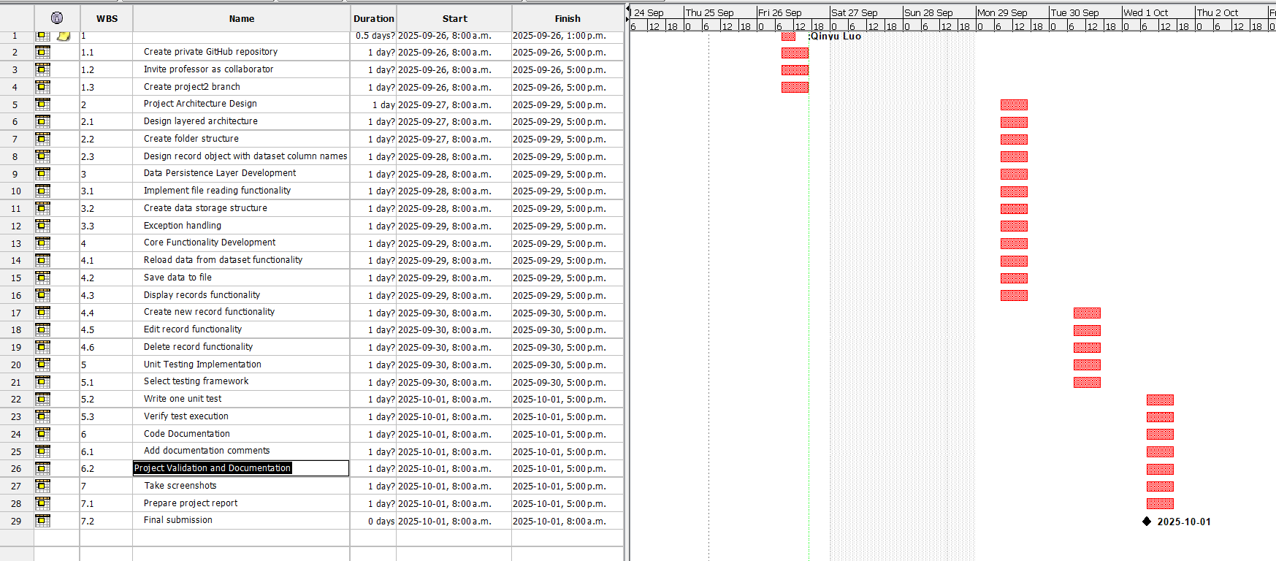

References

[1] | "MVC Design Pattern," 03 1 2025. [Online]. Available: https://www.geeksforgeeks.org/system-design/mvc-design-pattern/. [Accessed 25 09 2025].

